**LAB # 07**

**“ OPEN-ENDED LAB (MEDICAL DIAGNOSIS) ”**

* **OBJECTIVE:**

To develop a comprehensive medical diagnosis system using deep learning (TensorFlow/Keras) that implements linear regression for baseline analysis, single-layer perceptron with Adam optimizer, multi-layer neural networks with ReLU/Sigmoid activations, and a deep neural network for accurate disease prediction (diabetes detection).

* **LAB TASKS:**
* **CODE:**

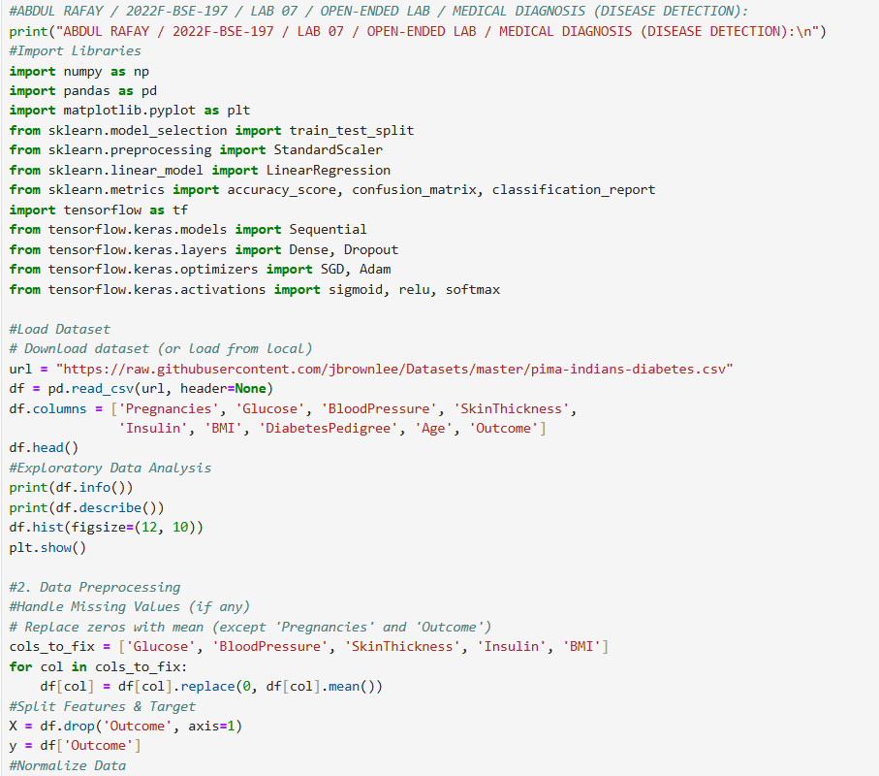

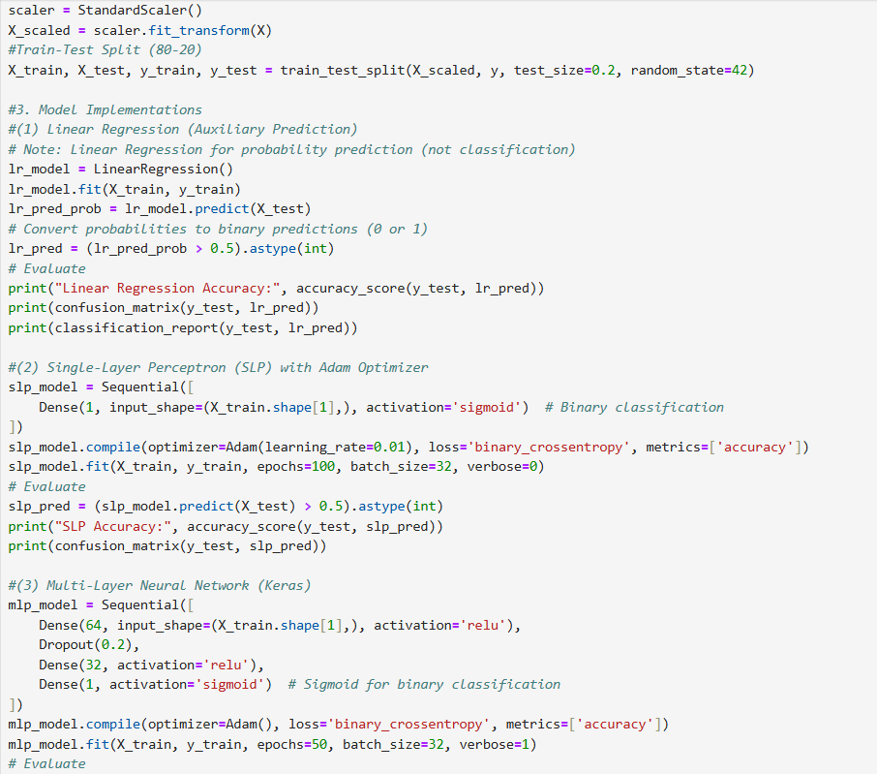

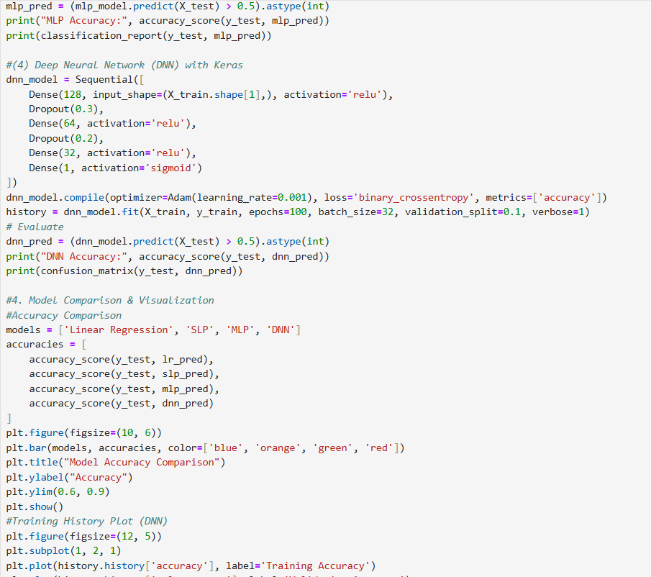

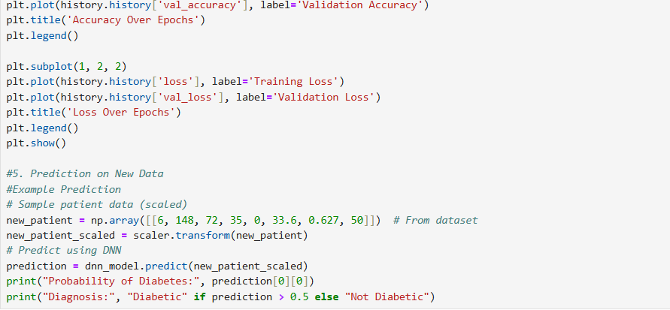

* **OUTPUT:**

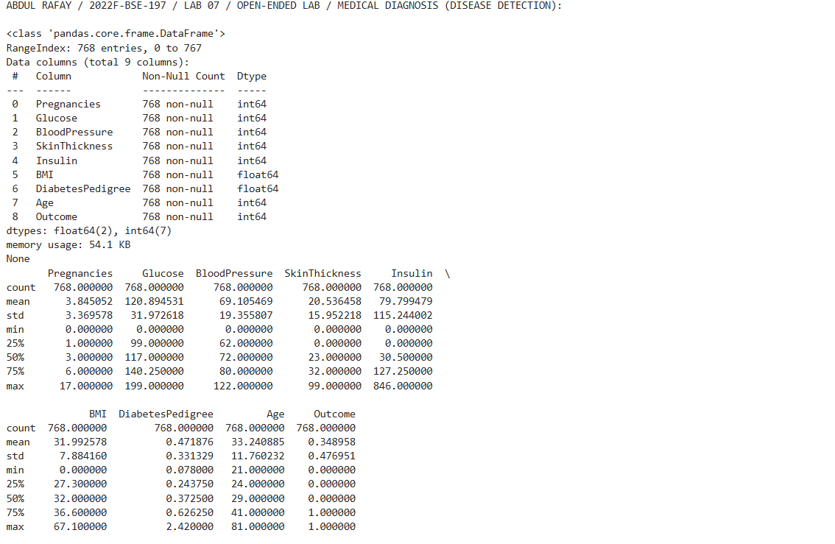

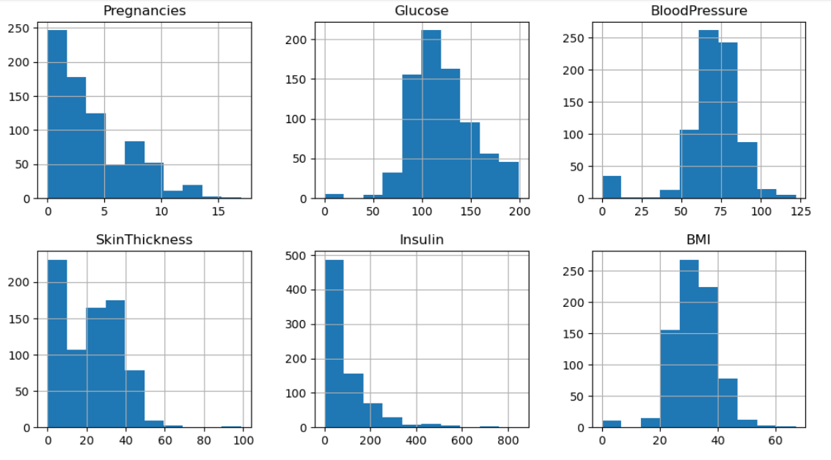

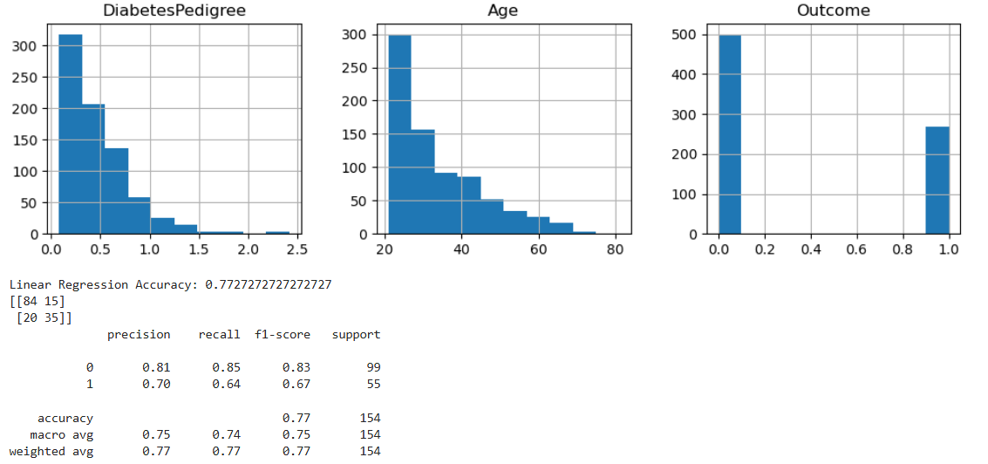

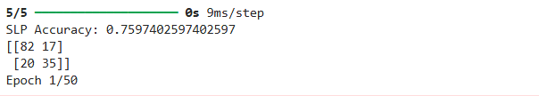

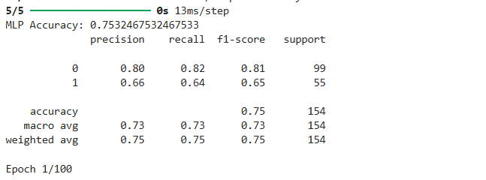

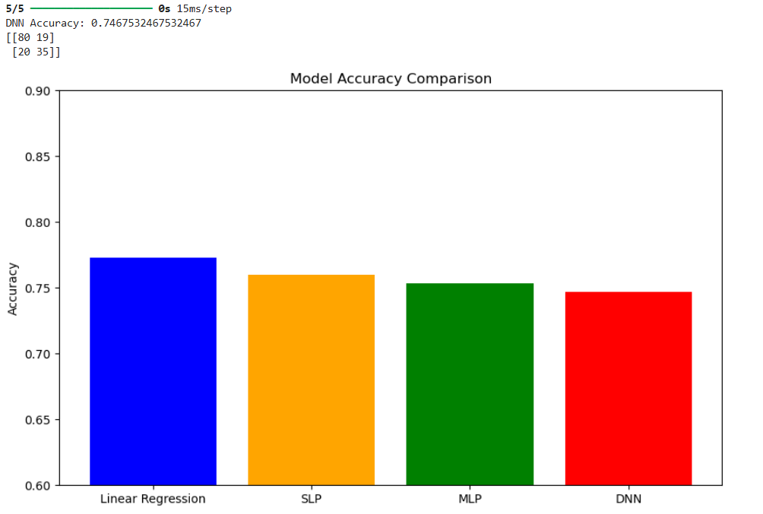

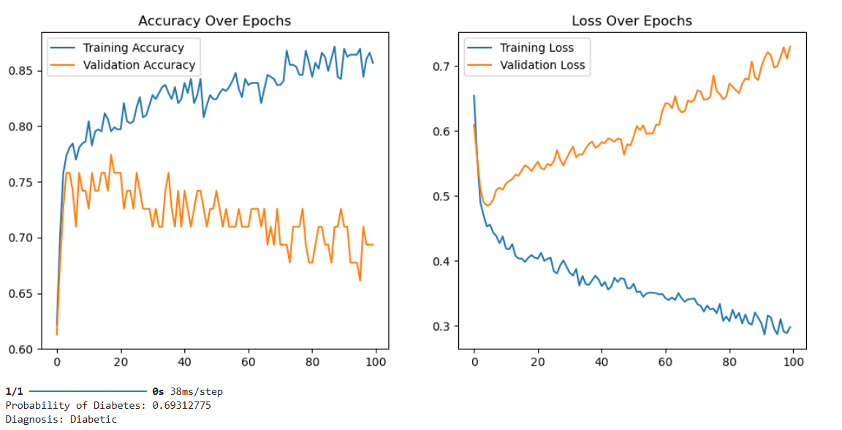

* **GITHUB UPLOAD:**

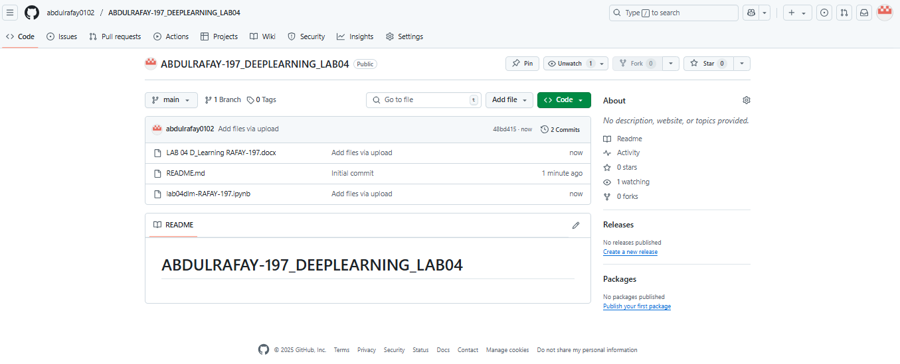

* **KAGGLE UPLOAD:**

